Ramapo Indian Hills
GRADE 11 Summer Reading 2019
This assignment is for all students enrolled in English 3 CP & English 3 CPE. *American Studies and English 3 Honors students: See assignments in bold.

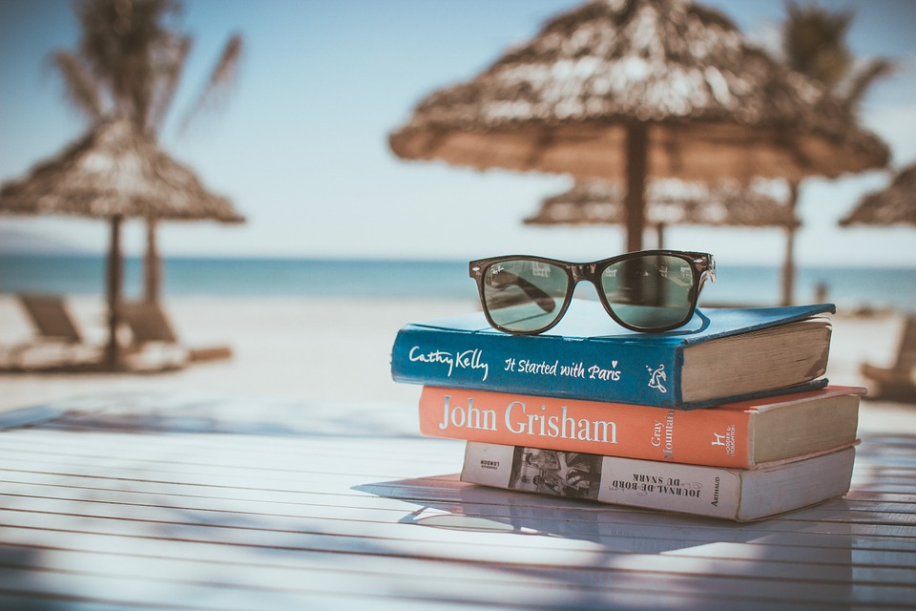

You can find magic wherever you look. Sit back and relax, all you need is a book! -Dr. Seuss

Reading is pleasurable and worthwhile. It offers you the opportunity to travel, to explore new places, and to experience a variety of interesting people and events all from the comfort of your own space. At the same time, reading a good book gives you a chance to practice your comprehension skills, to sharpen your reading rate, and to expand your vocabulary. Reading gives you the best of both worlds!

*All American Studies students are required to read Bread Givers by Anzia Yezierska. (You do NOT need to choose an additional title.)

*All English 3 Honors students are required to read Nickel and Dimed: On (Not) Getting By in America by Barbara Ehrenreich IN ADDITION TO any text of your choice. As you read, annotate for significant quotes and events that support the author’s purpose, and then complete your one page reaction to the text.

*All English 3 AP students--See separate assignment.

Please read the directions below:

- SELECT a book that you have not read before. It may be an intriguing new work of fiction, that dystopian novel your friends are talking about, or even a work of nonfiction about a subject you want to explore. Choose something that interests you! Consider consulting with your current teacher, school or town librarian, parents, and/or peers to help you with the selection process. You may also consult the ‘Book Selection Resources’ at the end of this assignment.

- ENJOY the read! You may wish (though it is not required) to take notes on the elements of narration (characters, setting, plot, conflict, themes, etc.) so that you can recall key points of your reading. You may also make notes or comments about your own personal responses, observations, or questions about what is happening in the book.

- REFLECT on your reading. Once you finish the book, write a one-page typed response. Briefly explain why you chose the book and then offer some reaction to it. This might be a personal, creative, or academic response---you decide! The important thing is that your response demonstrates the thinking that you did as a result of the reading. Whatever you do, do not simply summarize the book! (*Work will be submitted through Turnitin.com, an anti-plagiarism site, so be sure your work is original.)

- SHARE with your teacher and peers. Your thoughtful response to the book and your ability to discuss it in class will be the subject of one of the first assignments of school year. Your English teacher will provide more details in the first week of school. Just be sure to come to class with your book and a hard copy of your typed response on FRIDAY, SEPTEMBER 6, 2019.

SO GRAB YOUR SUNGLASSES... AND HAPPY READING!!!!

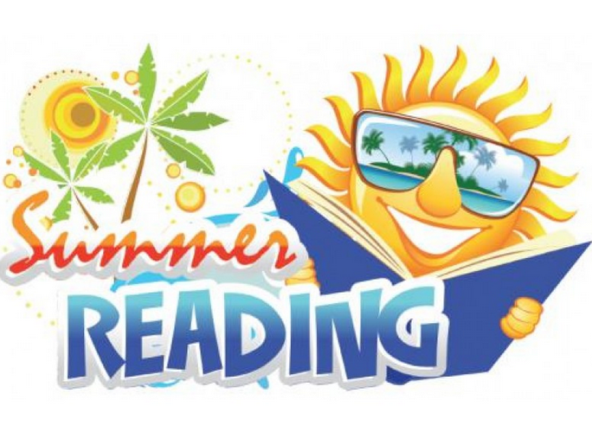

BOOK SELECTION RESOURCES

*Parents are urged to assist students in their text selections by consulting reviews at amazon.com and bn.com for additional information. Please be aware that some of the contemporary titles depict mature and/or controversial topics. Families are encouraged to review titles carefully prior to students’ text selections in order to choose the one that is the best fit for your student.

Websites:
https://www.barnesandnoble.com/blog/teen/the-best-young-adult-books-of-2017/
https://www.goodreads.com/list/show/43.Best_Young_Adult_Books

Suggested Titles:
(*These are merely suggestions! Feel free to choose a book that is not on the list.)

- Being Henry David by Cal Armistad
- The Boys in the Boat by Daniel James Brown
- Code Talker by Joseph Bruchac
- Ask Me No Questions by Marina Budhos
- Girl in Translation by Jean Kwok
- The Worst Hard Time by Timothy Egan
- The Lions of Little Rock by Kristin Levine
- Bodega Dreams by Ernesto Quinonez
- Always Running by Luis Rodriguez
- Scratch Beginnings by Adam Shepard
- A Hope in the Unseen by Ron Suskind
- Go Set a Watchman by Harper Lee
- How Soccer Explains the World by Franklin Foer
- The Arm: Inside the Billion-Dollar Industry of the Most Valuable Commodity in Sports by Jeff Passan
- Just Mercy by Bryan Stevenson
- Wild by Cheryl Strayed
- Aristotle and Dante Discover the Secrets of the Universe by Benjamin Saenz
- The Poisonwood Bible by Barbara Kingsolver
- The Wangs vs. The World by Jade Chang
- Stories of Your Life by Ted Chiang

